**Artificial Intelligence (LAB)**

**FA21-BCS-066**

**HUSSAIN ALI**

**BCS-7A**

# 

**Task 1**

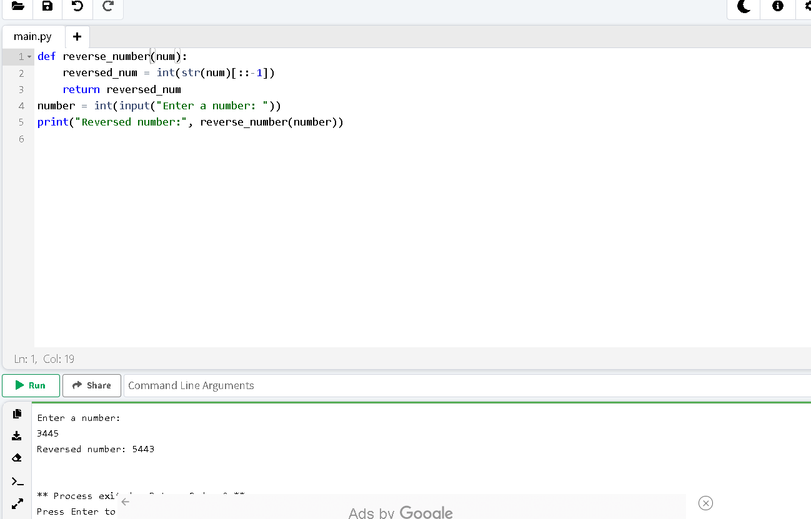

**Task 02**

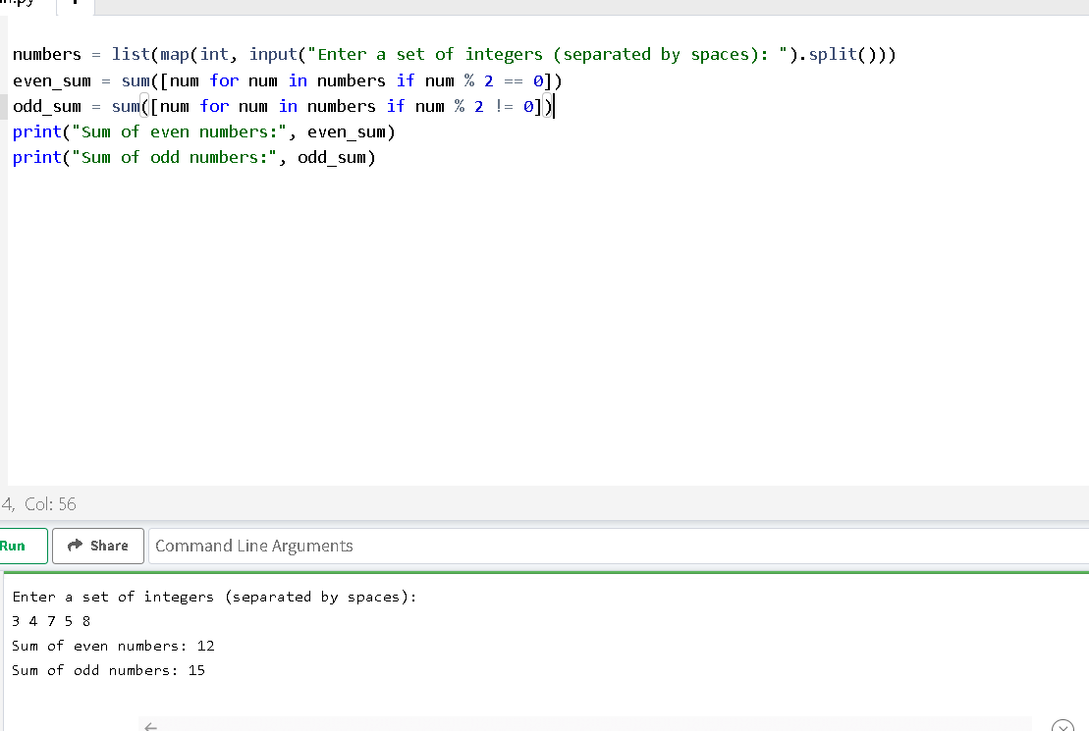

**Task 03**

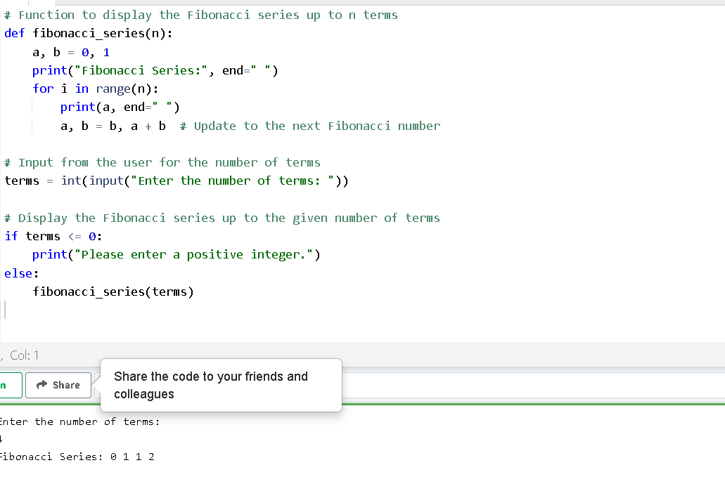

**Task 04**

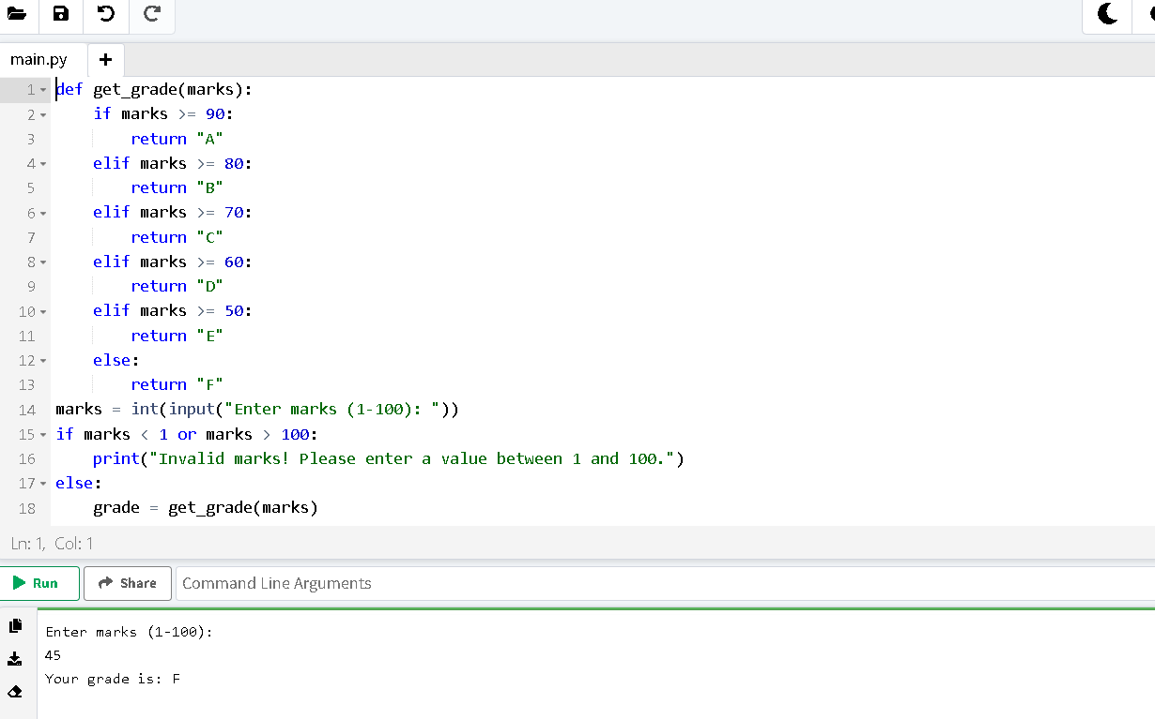

**Task 05**

